Software Requirements
Specification
for
Art Exhibition Management Database
Version 2.0 approved
Prepared by Priya J Shah (202512100)
Priya D Shah (202512105)

DAIICT
26-08-2025

Table of Contents
- Introduction
1.1 Purpose
1.2 Document Conventions
1.3 Intended Audience and Reading Suggestions
1.4 Product Scope
1.5 References
- Requirements Gathering
2.1 Summary of Collected Data
- Artwork Cataloguing Challenge
- Exhibition Scheduling Challenge
- Problem Statement and Solution
3.1 List of Requirements
3.2 Problems & Solutions
- Overall Description
4.1 Product Perspective
4.2 Product Functions
4.3 User Classes and Characteristics
4.4 Operating Environment
4.5 Design and Implementation Constraints
4.6 User Documentation
4.7 Assumptions and Dependencies
- External Interface Requirements
5.1 User Interfaces
5.2 Hardware Interfaces
5.3 Software Interfaces
5.4 Communications Interfaces
- System Features
6.1 Student and Artwork Management
6.2 Exhibition Scheduling and Venue Management
6.3 Judging and Award Management
6.4 Visitor Registration and Feedback
6.5 Reporting and Archiving
- Business Rules
7.1 Evaluation Rules
7.2 Data Retention
7.3 Compliance

Introduction

Purpose
- The Art Exhibition Management Database (AEMD) is designed to provide a centralized, smart, and efficient system for planning, managing, and archiving student art exhibitions within DAU’s M.Des program. Currently, there is no unified platform; records are maintained in physical registers or scattered spreadsheets, resulting in inefficiencies, errors, and a lack of transparency.

- The AEMD addresses these challenges by consolidating key processes—such as student and artwork records, venue scheduling, visitor registrations, judge evaluations, awards, and feedback management—into a single reliable platform. By digitalizing these workflows, the system ensures greater transparency, accuracy, and accountability while also creating a structured digital archive that documents and showcases student achievements over time.

- A unique feature of the AEMD is its Digital Artwork Portfolio, which allows each student to build and maintain a personal gallery reflecting their creative journey across multiple exhibitions. This not only simplifies exhibition management but also supports students in their academic growth, professional development, and creative recognition.

- Furthermore, by streamlining workflows such as artwork submissions, curation, judging, reporting, and feedback collection, the AEMD reduces administrative overhead, minimizes errors, and enhances the overall exhibition experience for all stakeholders—including administrators, students, judges, and visitors.

Document Conventions
This document follows the IEEE SRS standard format. Section numbering follows hierarchy (e.g., 1.1, 1.2, etc.).

Intended Audience and Reading Suggestions

Intended Audience:
This document is intended for all stakeholders involved in the design, development, and use of the Art Exhibition Management Database (AEMD):

- Program Administrators/Coordinators: To understand how the database supports exhibition planning, scheduling, and reporting.
- Faculty/Curators: To see how the system enables artwork submissions, selections, and layout planning.
- Student Artists: To understand how their submissions, statements, and awards will be managed.
- Judges: To review how evaluations, scoring, and feedback are structured.
- Visitors/Attendees: To see how registrations, ticketing, and feedback collection are handled.
Developers & Database Designers: To implement system requirements accurately.
Testers: To validate that requirements are fulfilled correctly.

Reading Suggestions:
- Program Administrators/Coordinators: Focus on sections detailing Exhibition Planning, Scheduling, Reporting, and User Management to understand operational workflows.
- Faculty/Curators: Review Artwork Submission, Selection Processes, Curation & Layout Planning, and Digital Portfolio Management.
- Student Artists: Concentrate on Artwork Submission Guidelines, Portfolio Features, Award Tracking, and Feedback Mechanisms.
- Judges: Refer to Evaluation Workflows, Scoring System, and Feedback Collection to understand assessment procedures.
- Visitors/Attendees: Focus on Registration, Ticketing, Event Access, and Feedback Submission sections for a clear view of participation.
- Developers & Database Designers: Study Functional Requirements, System Architecture, Data Models, and Integration Details to implement the system accurately.
- Testers: Review Use Cases, Functional & Non-Functional Requirements, and Validation Criteria to ensure correct implementation.

Product Scope
The AEMD is envisioned as DAU’s first digital exhibition management solution. It will centralize all exhibition activities—exhibition management, student submissions, venue scheduling, judging, visitor management, awards, and feedback. With no prior database, this system is critical to addressing inefficiencies, data redundancy, and transparency issues. In addition, it will create a permanent digital archive of exhibitions and student portfolios. The scope also includes extensibility for future features like online exhibitions and external platform integration.
Key Benefits:
- Introduces DAU’s first centralized art exhibition system.
- Eliminates manual errors and inefficiencies.
- Creates lasting digital archives for institutional and student recognition.
- Store exhibition details, venues, schedules, and themes.
- Establishes a foundation for future online and hybrid exhibitions.
- Generate reports on participation, evaluations, footfall, and feedback.
- Manage student profiles, artwork submissions, media assets, and metadata.
- Facilitate scoring, criteria-based evaluations, and award allocation.
- Support visitor registration, ticketing, QR check-ins, and feedback collection.

References
➤ A Database Model for Gallery or Museum Management
https://vertabelo.com/blog/a-database-model-for-gallery-or-museum-management/
➤ Create an Art Gallery Database in 3 Steps
https://five.co/blog/create-an-art-gallery-database/
➤ Art Gallery Management System using PHP and MySQL
https://phpgurukul.com/art-gallery-management-system-using-php-and-mysql/
➤ Art Gallery Database Management Project (GitHub Repository)
https://github.com/gauravp1996/Arts-gallery-database-management
➤ Database Design Project: Art Gallery Management System
https://desklib.com/study-documents/database-art-gallery-design/

Requirements Gathering
To better understand the challenges and requirements in managing art exhibitions at DAU, a research questionnaire was developed and circulated among students, visitors, judges, and faculty members. The aim of this questionnaire was to gather firsthand insights into the current issues faced in exhibition management and to identify the features that users expect from a digital Art Exhibition Management System. The responses collected from different stakeholders provided valuable input for shaping the system requirements, ensuring that the final product addresses real user needs and enhances the overall exhibition experience.
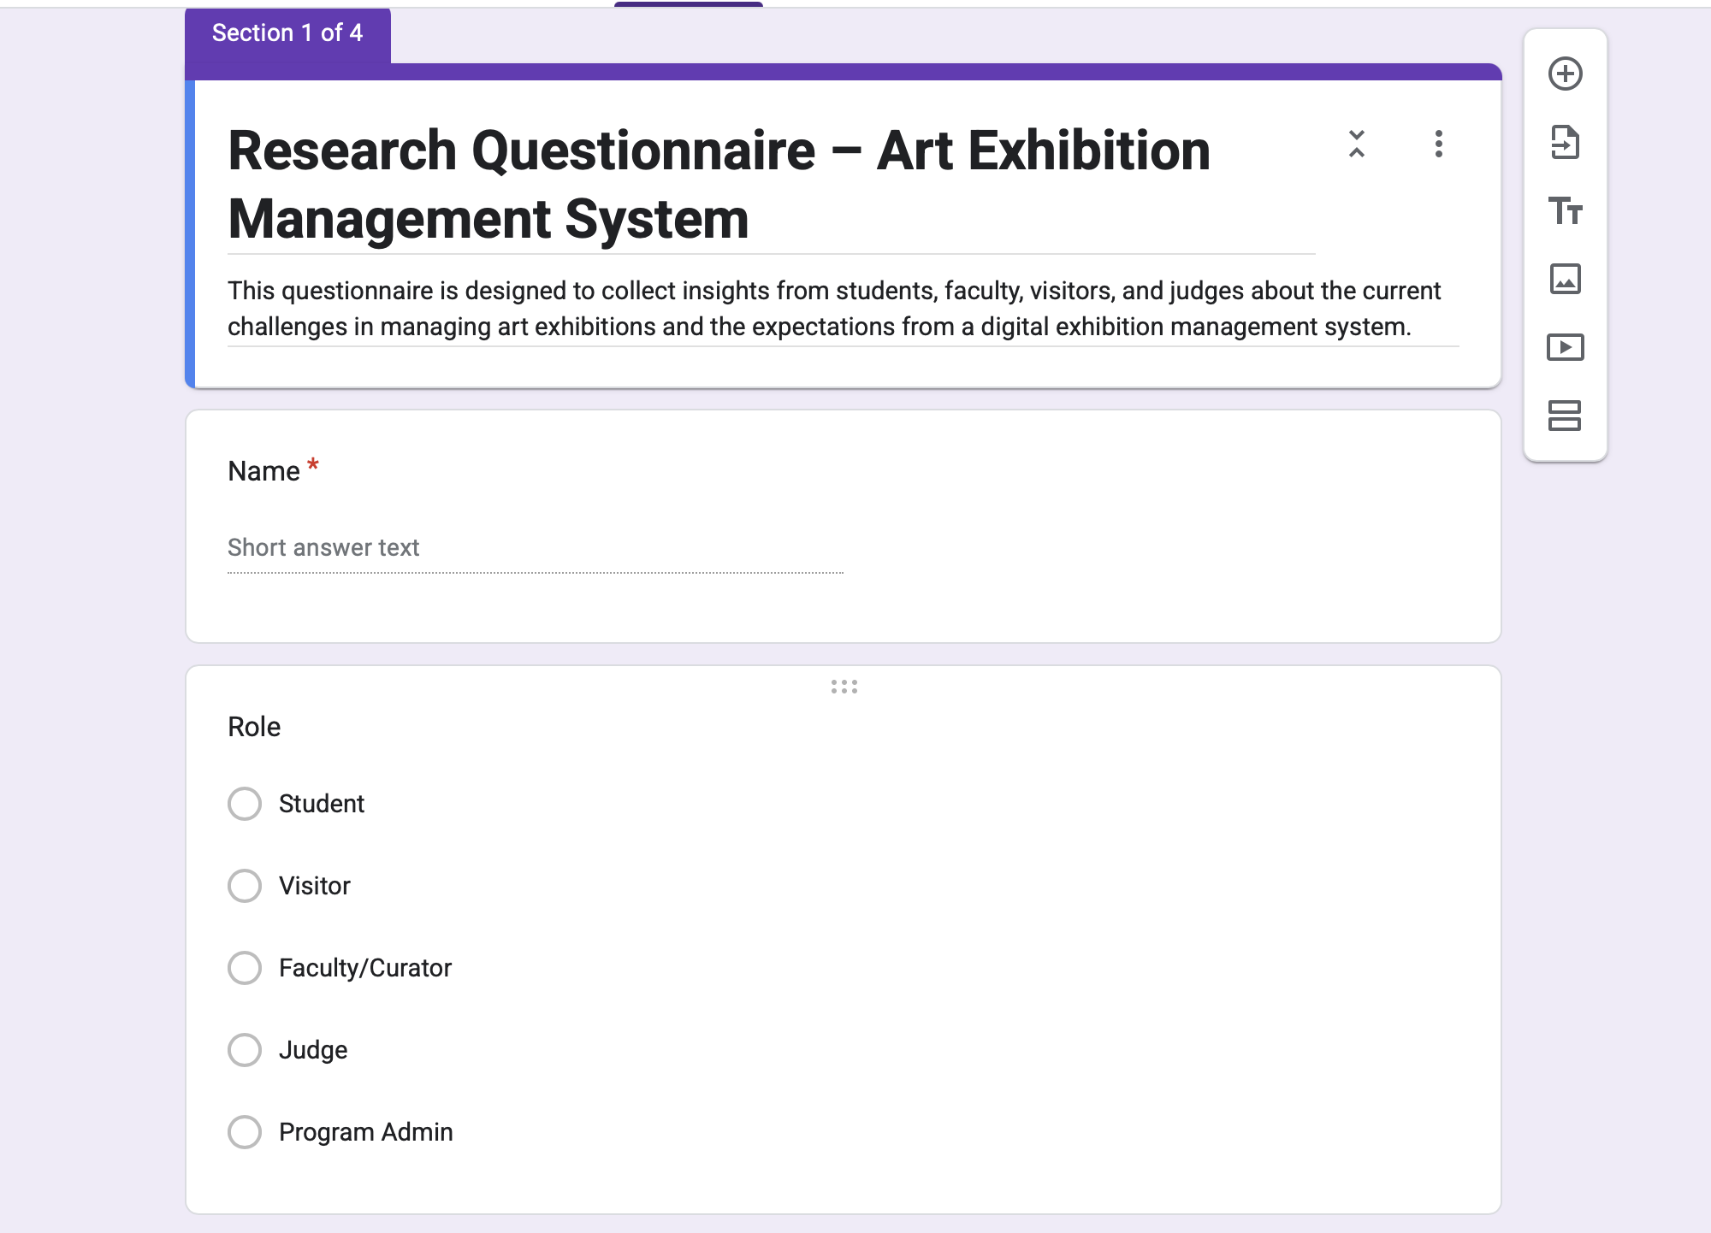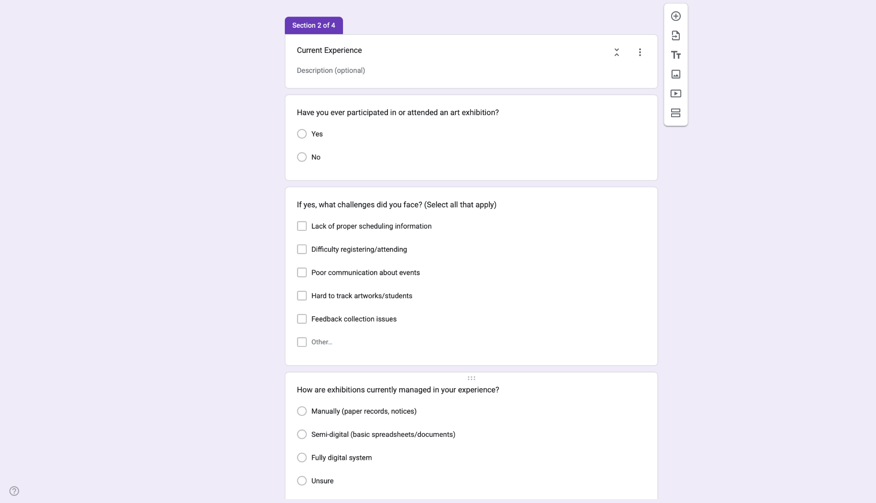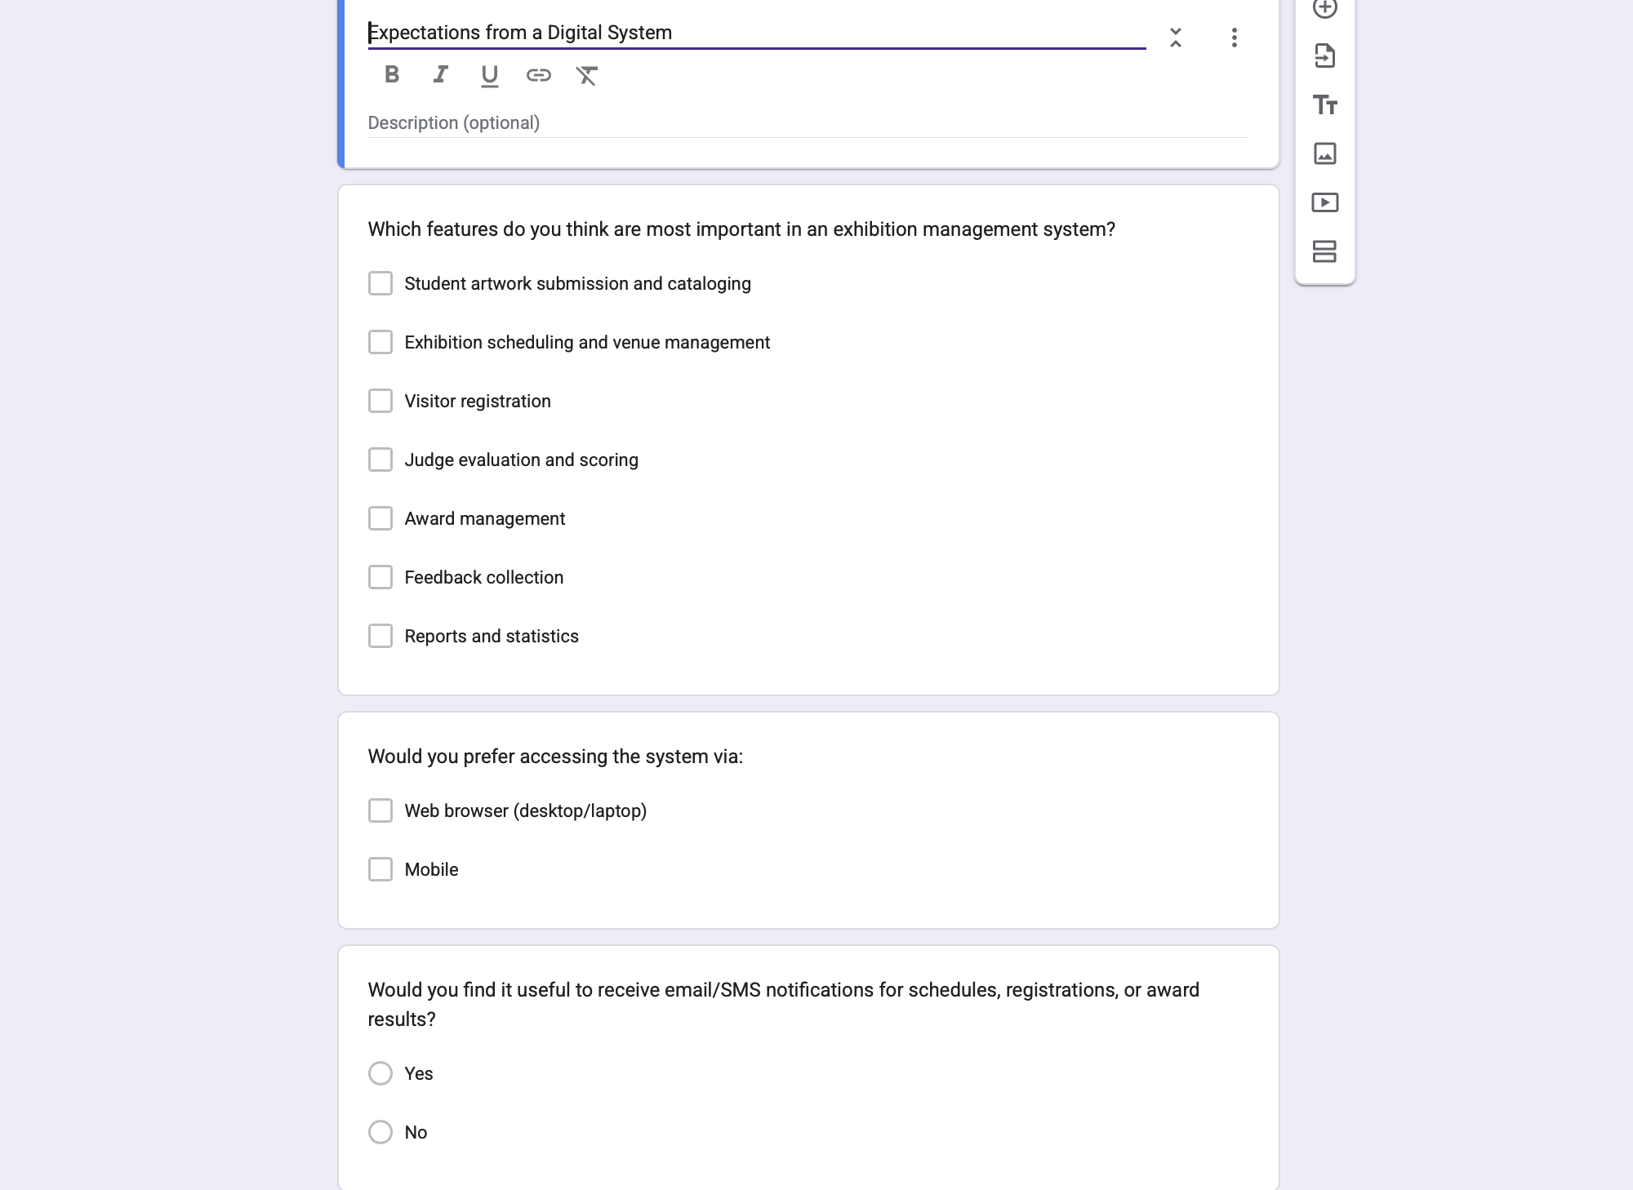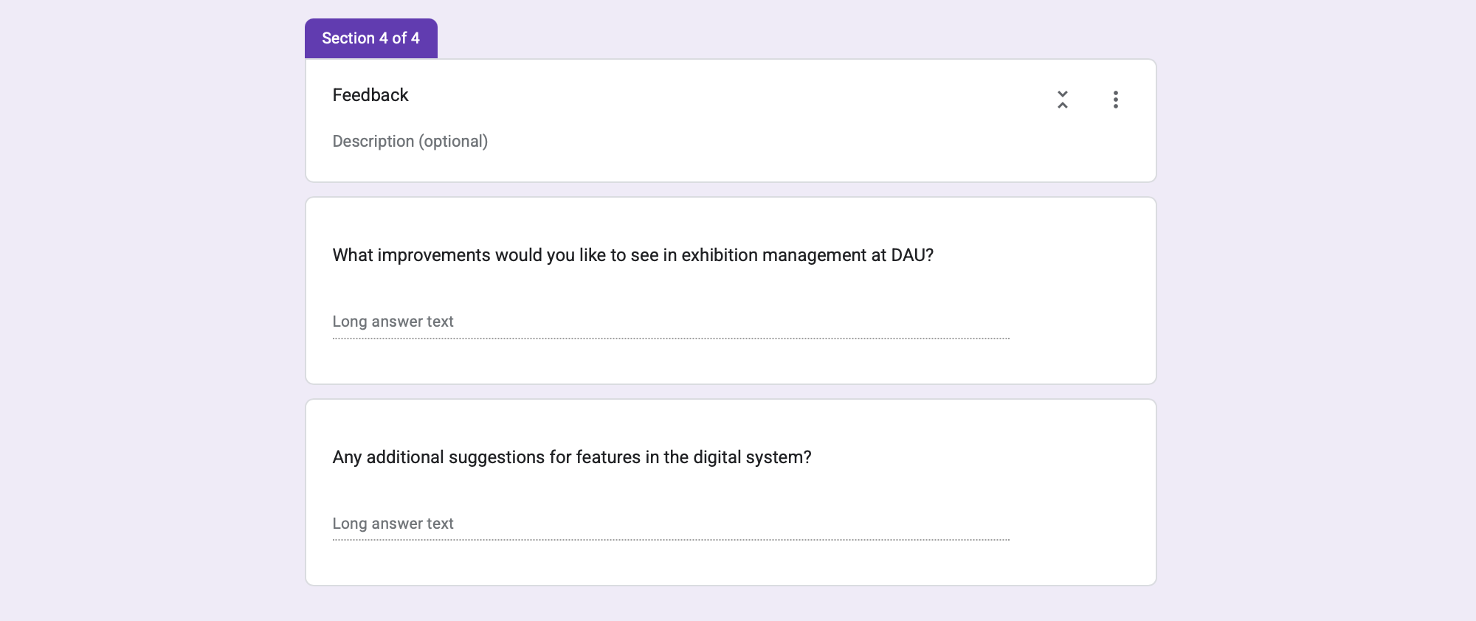

6.2 Summary of Collected Data
During the requirement gathering process, it was identified that students and administrators face significant challenges in managing the institution’s art-related activities effectively.
- Artwork Cataloguing Challenge:
Students often struggle to catalogue their artworks systematically, as manual methods like spreadsheets or physical records are inconsistent and prone to data loss. Key information such as title, medium, creation date, and descriptions is often missing, complicating exhibitions and portfolio management. The proposed system provides a digital platform to upload artworks with metadata, organize them into portfolios, and maintain a searchable archive.
- Exhibition Scheduling Challenge:
Administrators often struggle with scheduling exhibitions, leading to overlaps, venue conflicts, and missed deadlines. The system will provide a digital calendar to create events, assign venues, detect conflicts, and send automated reminders, improving efficiency and transparency.
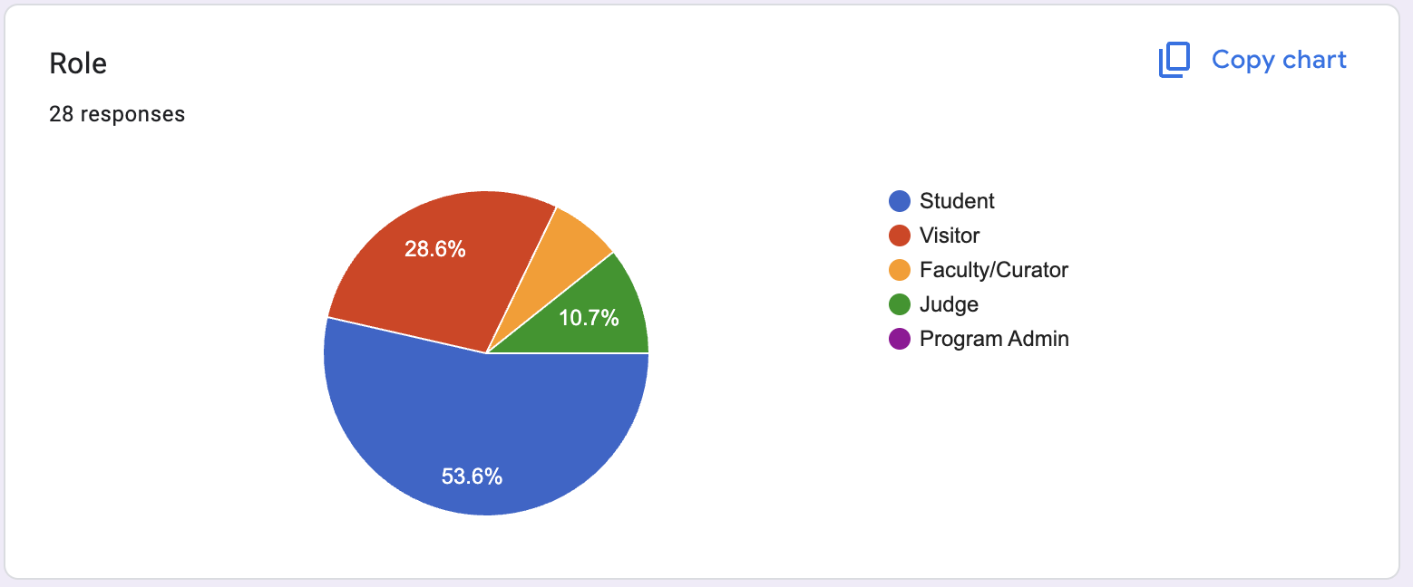
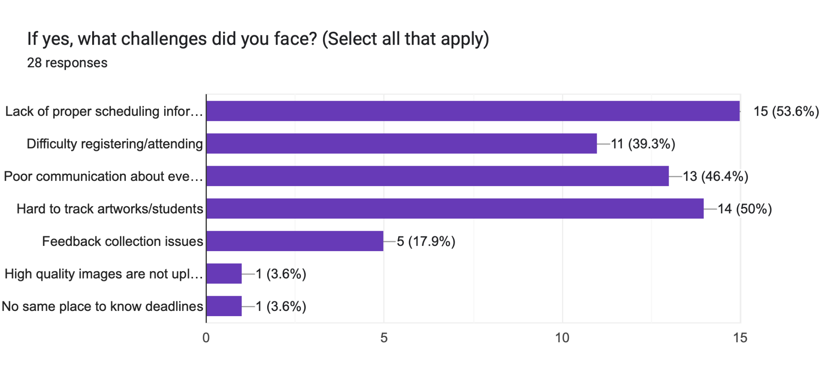
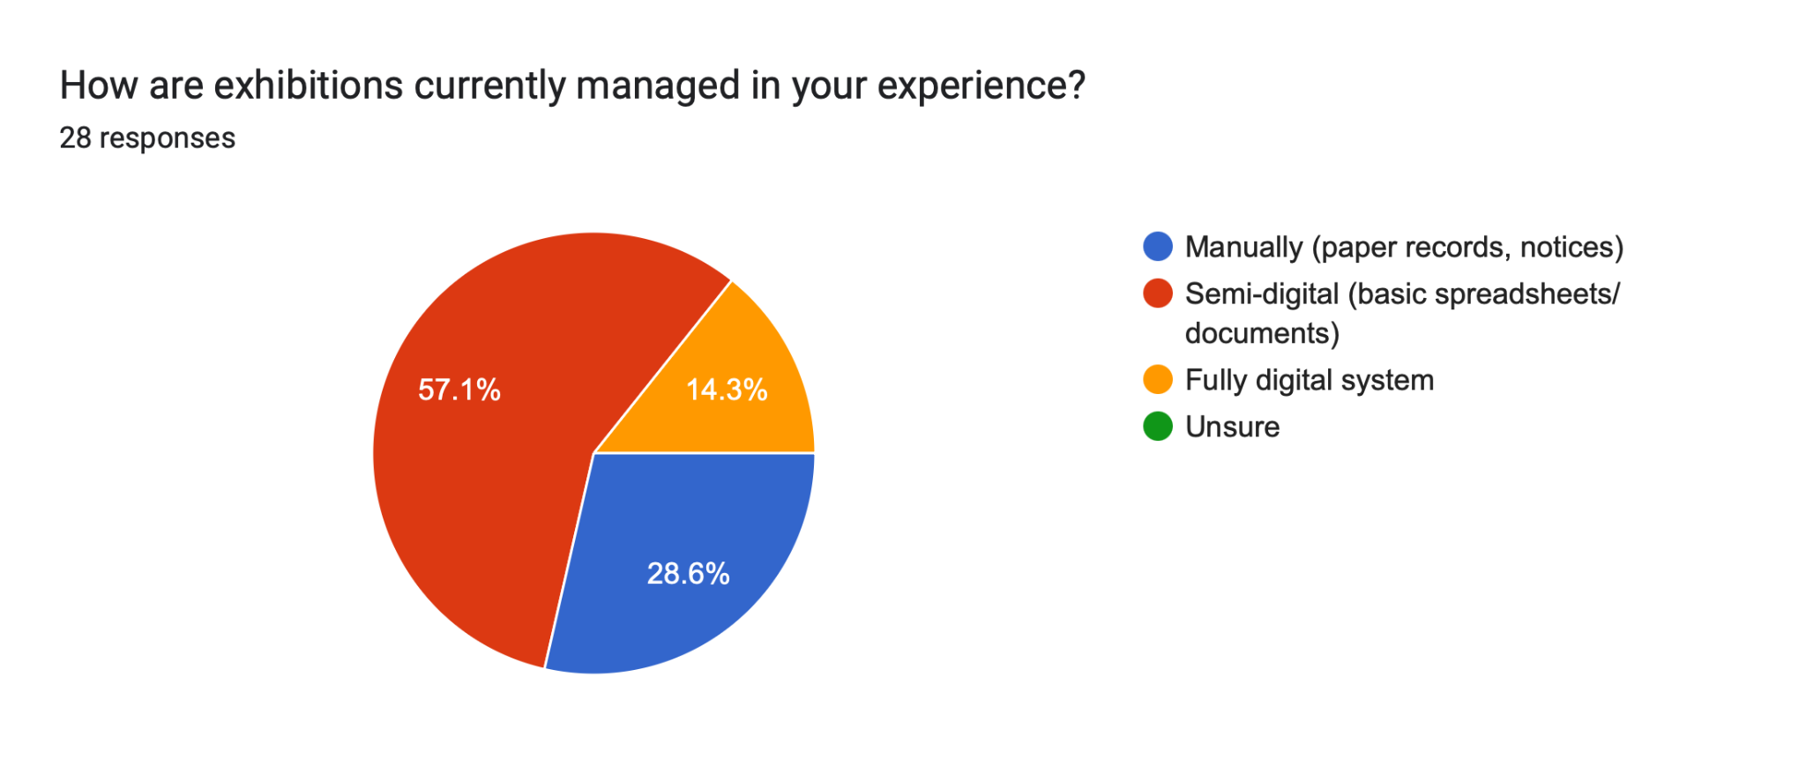
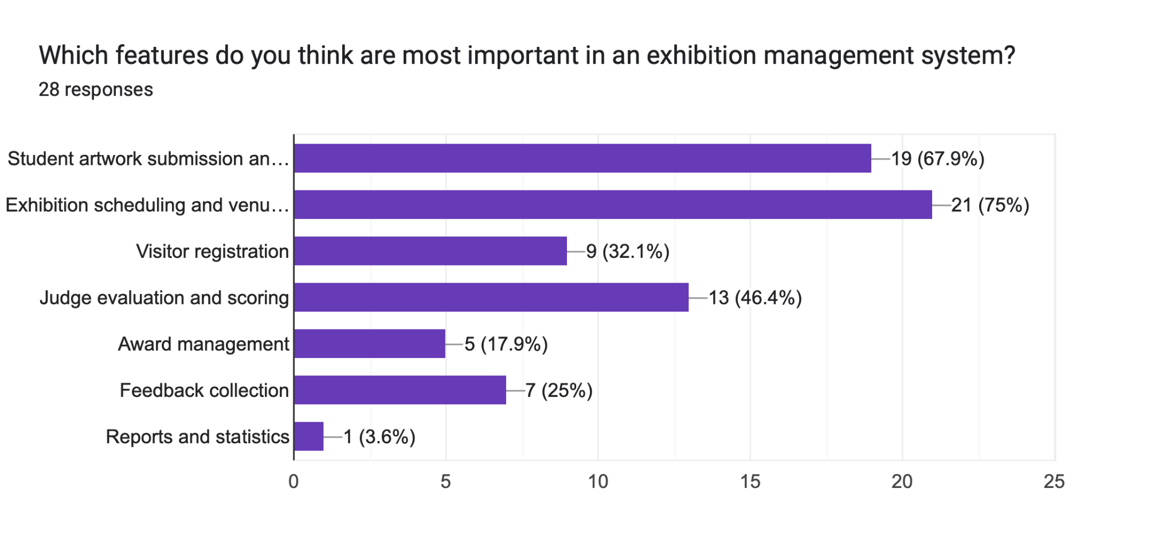
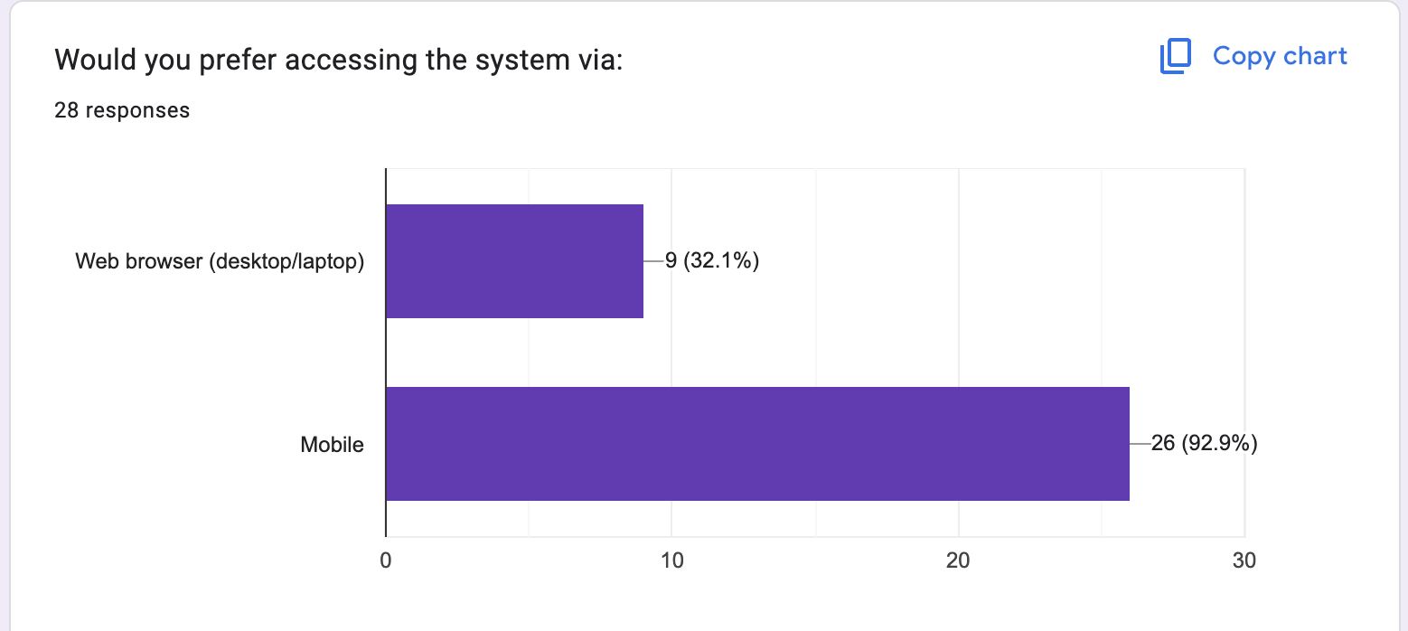

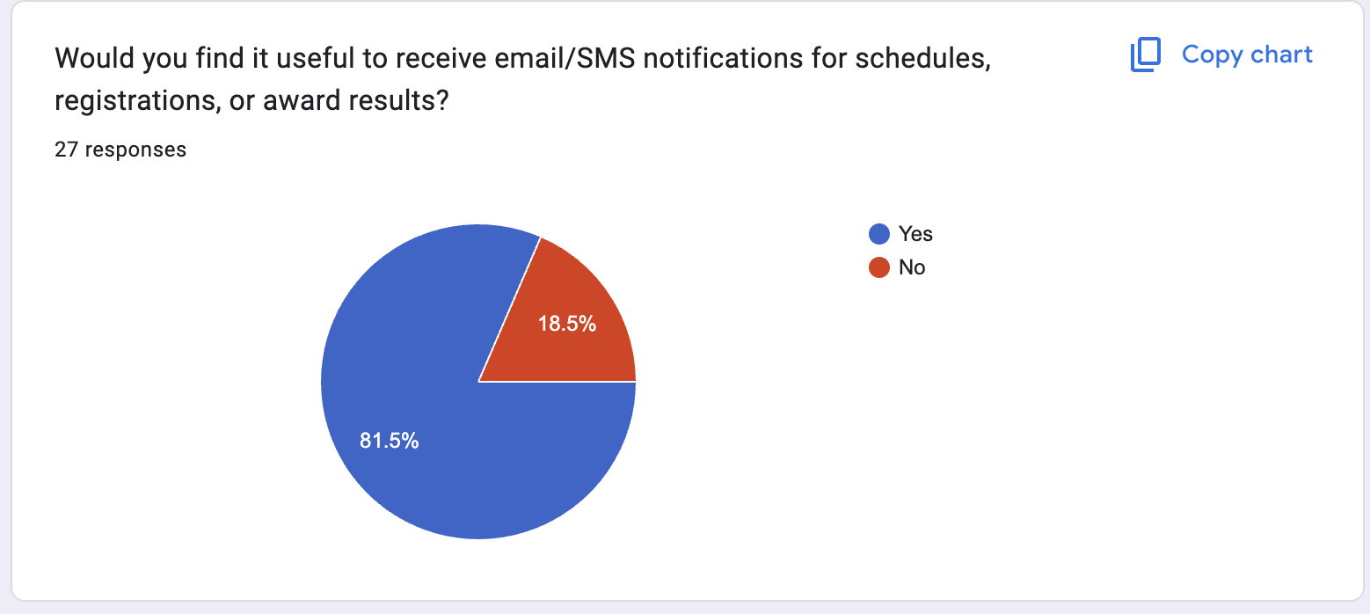
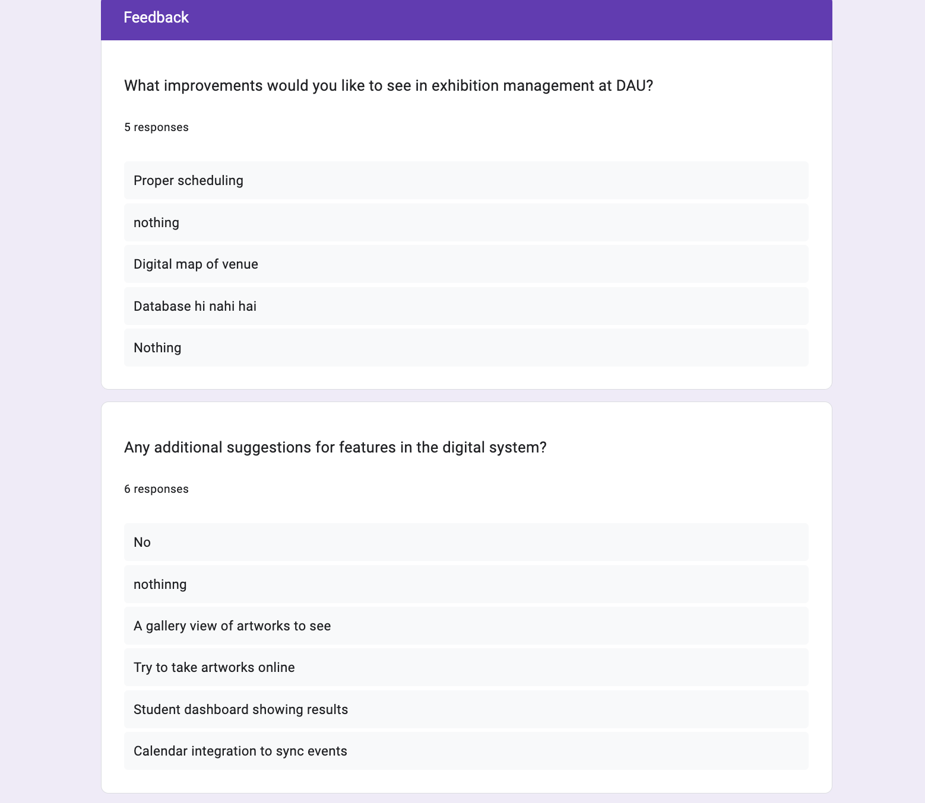

Problem Statement and Solution

List of Requirements:
    - There should be role-based access (Admin, Students, Judges, Visitors, Organizers).
    - There should be a centralized portfolio system to store and maintain student details, artworks, and achievements.
    - The system should provide real-time notifications for deadlines, results, and upcoming events.
    - There should be an evaluation and scoring system for student artworks/projects.
    - The system should ensure timely reminders for submissions and event participation.
    - It should be secure, user-friendly, and accessible across multiple devices.

Problems & Solutions

Data should be organized to allow easy tracking of student growth over time.
PROBLEM: Student portfolios and artwork details are scattered in multiple files, making it difficult for organizers to track submissions, achievements, and previous records. This causes delays when preparing reports or showcasing student talent.
SOLUTION: Implement a centralized portfolio management system where all student profiles, artworks, and achievements are stored. Each student can update their portfolio, and organizers/judges can access it easily for evaluation and exhibitions.
PROBLEM: Students often miss submission deadlines for exhibitions or competitions because there are no timely reminders. Organizers struggle to track who submitted on time and who didn’t.
SOLUTION: The system will send real-time notifications and reminders (via email/SMS/app alerts) about submission deadlines, upcoming exhibitions, and important announcements. This ensures that students stay updated and deadlines are not missed.
PROBLEM: Evaluation of artworks during exhibitions is usually manual, leading to delays, inconsistency, and sometimes bias. Scores are not properly recorded or communicated to students.
SOLUTION: Introduce a digital scoring and evaluation system where judges can enter scores directly into the system. Results are automatically calculated, stored, and shared with students through notifications. This ensures transparency and fairness in assessments.
PROBLEM: After events, there is no proper system to showcase student performance, achievements, or growth over multiple exhibitions. This makes it difficult for both students and institutions to track progress.
SOLUTION: The database will maintain a long-term record of student portfolios, scores, and achievements. This data can be used to generate performance reports, which help students build a professional portfolio and help organizers identify top talent.
With this approach, the Art Exhibition Database will not just manage exhibitions but also become a complete student portfolio & performance management system — helping students, organizers, and judges equally.

Overall Description

Product Perspective
Since DAU does not currently have an art exhibition database, the Art Exhibition Management Database (AEMD) will be developed from scratch as a standalone solution. It will replace fragmented manual processes with a unified digital platform that streamlines all exhibition activities.
Students will digitally register and submit their artworks, coordinators will manage schedules and venues efficiently, and judges will input evaluations directly to ensure fairness and transparency. Visitors can register online, reducing queues and errors during check-in.
In addition, the system will maintain a digital archive of student artworks, creating personal portfolios that showcase creative growth over time. This transition from no system to a fully functional database represents a major step toward efficiency, accuracy, and long-term value for students and administrators alike.
  - Product Functions
- Maintaining Student and Artwork Records – The system will keep complete details of each student along with the artworks they submit. This ensures that information is stored in an organized and easily retrievable manner.
- Handling Registrations – Students can register for different exhibitions through the system, and their entries will be recorded without the need for manual paperwork.
- Managing Schedules and Venues – Exhibition dates, timings, and venue details will be properly maintained in the database, helping organizers avoid scheduling conflicts and ensuring smooth event planning.
- Supporting Judge Evaluations – Judges will be able to view student artworks through the system and directly enter their evaluations and scores, making the process faster and more reliable.
- Recording Awards and Achievements – The system will maintain records of awards given to students, creating a clear history of achievements for future reference.
- Generating Reports – Important reports such as participant lists, exhibition schedules, evaluation results, and award winners can be created instantly without manually re-typing data.
- Maintaining Artwork Portfolios – Over time, the system will build a digital portfolio for every student by keeping track of all the artworks they have submitted in different exhibitions. This gives students a lasting collection of their creative work.

User Classes and Characteristics
The Art Exhibition Management Database will be used by different types of users, each with their own roles and responsibilities:
- Students: Submit artworks, maintain digital portfolios, and track awards and recognitions over time.
- Organizers/Administrators: Plan and manage exhibitions, handle schedules and venues, and generate detailed reports.
- Judges: Evaluate artworks systematically using structured rubrics and record scores digitally.
- Faculty/Management: Oversee exhibition processes, monitor outcomes, and ensure smooth operations.
- Visitors: Register online, check in efficiently, and provide feedback through the system.

Operating Environment
- Hardware: Standard desktops/laptops (4 GB RAM, 500 GB storage).
- Software: Relational databases (MySQL/PostgreSQL), Django or PHP for backend, HTML/CSS/JS for frontend.
- OS: Platform-independent (Windows/Linux/macOS).
- Network: LAN and internet-enabled deployment.

Design and Implementation Constraints
While designing and implementing the Art Exhibition Management Database, a few limitations and conditions need to be considered:
- System Compatibility – The application should be able to run smoothly on commonly available college lab systems without requiring high-end hardware. This ensures that students, faculty, and organizers can easily access it without additional costs.
- Data Security and Accuracy – The database must be designed to prevent redundancy (duplicate records) and maintain data integrity. Proper security measures should also be in place so that sensitive details such as student records, judge evaluations, and awards cannot be tampered with.
- User Interface Simplicity – Since not all users are technically skilled, the user interface should be simple and easy to understand. Both students and faculty should be able to navigate the system without difficulty.
- Resource Limitations – The system will be developed under limited budget and resources. As a result, advanced features like Artificial Intelligence-based recommendations or a mobile application may not be included in the first version but can be considered for future upgrades.

User Documentation
To make the system easy to use, proper documentation will be provided for all types of users. This will help students, faculty, judges, and organizers understand how to use the system effectively.
- User Manual – A detailed user manual will be provided, explaining step-by-step how to perform different tasks such as registering for exhibitions, uploading artworks, scheduling exhibitions, entering evaluations, and generating reports.
- Quick Start Guide – For first-time users, a simple guide with screenshots will be included. This will give a quick overview of the most common tasks, making it easier for beginners to get started without confusion.
- Help Section – The system will also include a built-in help or FAQ section that provides answers to frequently asked questions. This feature will allow users to resolve small issues on their own without needing external support.

Assumptions and Dependencies
While developing and using the Art Exhibition Management Database, certain assumptions and dependencies are considered:
- User Knowledge – It is assumed that all users of the system, including students, judges, and organizers, will have basic computer knowledge. This will allow them to operate the system without extensive training.
- Network Availability – If the system is deployed online, it is assumed that a reliable internet connection or LAN will be available to ensure smooth access for all users.
- Secure Access – Each user will be provided with valid login credentials. This assumption ensures that only authorized users can access the system, keeping the data safe and secure.
- Hardware and Backup Support – The database will depend on reliable server hardware to store and process data efficiently. Regular backups will also be necessary to avoid data loss in case of hardware failure or unexpected issues.
- Future Enhancements – It is assumed that the system can be extended in the future with advanced features such as mobile applications, online ticketing for exhibitions, or integration with other digital platforms, depending on available resources.

External Interface Requirements
  - User Interfaces
The AEMD will feature a web-based graphical user interface (GUI) designed for intuitive navigation and accessibility. Key elements include:

- Login and Dashboard Screens: Role-based dashboards (e.g., student view showing portfolio and submissions; admin view with scheduling tools) using responsive design for desktop and mobile devices (HTML5, CSS3, Bootstrap framework).
- Forms and Inputs: Interactive forms for artwork submission (with file uploads for images/videos), visitor registration (QR code generation), and judge evaluations (scoring sliders and comment fields).
- Visualization Tools: Gallery views for artworks (grid or carousel layouts), calendar interfaces for schedules (using libraries like FullCalendar), and report generators with export options (PDF/CSV).
- Accessibility Features: Compliance with WCAG 2.1 standards, including alt text for images, keyboard navigation, and screen reader support to accommodate diverse users, such as those with visual impairments.
- Error Handling: User-friendly messages (e.g., "Invalid file format—please upload JPG/PNG") and tooltips for guidance.
- The interface will prioritize simplicity, as noted in the design constraints, to ensure non-technical users (e.g., students and visitors) can operate it without training.

Hardware Interfaces
The AEMD will interface with standard hardware commonly available in educational environments:
- Input Devices: Keyboards, mice, and touchscreens for data entry; webcams or scanners for uploading artwork images if integrated with physical submissions.
- Output Devices: Monitors/printers for viewing dashboards and generating reports; mobile devices for on-the-go access (e.g., QR code scanning for visitor check-ins using smartphone cameras).
- Storage and Processing: Server hardware with at least 4 GB RAM and 500 GB storage for hosting the database; no specialized hardware required beyond standard desktops/laptops as specified in the operating environment.
- Peripheral Support: Optional integration with barcode/QR scanners for event check-ins to reduce manual entry errors during exhibitions.
- The system assumes reliable hardware availability and does not impose high-end requirements to align with budget constraints.
  - Software Interfaces
The AEMD will integrate with external software components to enhance functionality:
- Database Management System: Interfaces with relational DBMS like MySQL or PostgreSQL via SQL queries for data storage and retrieval (e.g., JDBC/ODBC drivers for connectivity).
- Backend Frameworks: Django (Python-based) or PHP for server-side logic, handling API calls for features like artwork uploads and report generation.
- Google Maps API for venue location mapping and directions.
- Email services (e.g., SMTP via Gmail API or SendGrid) for notifications (e.g., submission confirmations, award announcements).
- File storage APIs (e.g., AWS S3 or local file system) for handling multimedia artworks.
- Export/Import Tools: Support for CSV/JSON imports from legacy spreadsheets and exports to PDF tools (e.g., via libraries like ReportLab in Python).
All interfaces will use standard protocols to ensure compatibility, with error logging for failed integrations.
  - Communications Interfaces
The AEMD will use standard network protocols for data exchange:
- Network Protocols: HTTP/HTTPS for secure web access; TCP/IP for LAN/internet connectivity to support remote access by users.
- Data Transmission: SSL/TLS encryption for all communications involving sensitive data (e.g., user registrations, judge scores) to prevent interception.
- Notification Systems: SMTP for email alerts (e.g., "Your artwork has been selected") and optional SMS integration via APIs like Twilio for real-time updates.
- Bandwidth Requirements: Low to moderate (e.g., <1 Mbps per user) for text-based operations; higher for multimedia uploads (up to 10 Mbps recommended).
- Fallback Mechanisms: Offline caching for mobile views (using service workers in progressive web app design) in case of intermittent connectivity.
These interfaces ensure reliable, secure communication, assuming stable network availability as per the assumptions section.

System Features
This section details the prioritized functional features of the AEMD, organized logically based on user workflows. Each feature includes a description, priority (high/medium/low), stimulus/response sequences, and associated functional requirements. Features are derived from the product functions outlined earlier and address the unique issue of biased, inefficient curatorial processes by incorporating data-driven tools.

Student and Artwork Management
- Description: Allows students to register profiles, submit artworks with metadata (e.g., title, medium, description), and build digital portfolios. Administrators can review and curate submissions using multi-attribute scoring (e.g., novelty, accessibility) to reduce subjectivity.
- Priority: High.
- Stimulus/Response Sequences:
- Stimulus: Student uploads artwork file and metadata via form.
- Response: System validates file (e.g., size <10MB, formats: JPG/PNG/MP4), stores in database, and notifies admin.
- Stimulus: Admin applies scoring framework.
- Response: System generates ranked list based on weighted criteria.
- Functional Requirements:

REQ-1.1: Support multimedia uploads with metadata fields.
REQ-1.2: Automate portfolio updates linking artworks to student profiles.
REQ-1.3: Implement decision-making tool for curation (e.g., weighted average scoring).

Exhibition Scheduling and Venue Management
- Description: Enables administrators to create exhibitions, assign venues, set schedules, and check for conflicts. Includes calendar views and automated reminders.
- Priority: High.
- Stimulus/Response Sequences:

- Stimulus: Admin inputs exhibition details (date, theme, venue).
- Response: System checks availability and reserves venue.
- Stimulus: Conflict detected.
- Response: Alerts user with alternative suggestions.
- Functional Requirements:

- REQ-2.1: Integrate calendar API for visual scheduling.
- REQ-2.2: Generate conflict reports and notifications.

Judging and Award Management
- Description: Provides judges with access to artworks for scoring based on predefined rubrics. System tallies scores, assigns awards, and records them in student profiles.
- Priority: Medium.
- Stimulus/Response Sequences:
- Stimulus: Judge views assigned artworks.
- Response: System displays rubric form for input.
- Stimulus: Scores submitted.
- Response: Aggregates results and notifies winners.
- Functional Requirements:

- REQ-3.1: Role-based access for judges.
- REQ-3.2: Automated award allocation based on thresholds (e.g., top 10% scores).

Visitor Registration and Feedback
- Description: Handles online registrations, QR check-ins, and post-event feedback collection. Analyzes feedback for reports.
- Priority: Medium.
- Stimulus/Response Sequences:
- Stimulus: Visitor registers via web form.
- Response: Generates QR ticket and confirmation email.
- Stimulus: Feedback form submitted.
- Response: Stores data and updates analytics dashboard.
- Functional Requirements:

- REQ-4.1: QR code generation and scanning integration.
- REQ-4.2: Feedback analytics (e.g., average ratings).

Reporting and Archiving
- Description: Generates customizable reports on exhibitions, participation, and feedback. Maintains a digital archive for historical access.
- Priority: Low (for advanced analytics).
- Stimulus/Response Sequences:
- Stimulus: User requests report (e.g., award winners).
- Response: System queries database and exports file.
- Functional Requirements:
- REQ-5.1: Support for PDF/CSV exports.
- REQ-5.2: Archive search functionality by year/student.

Business Rules

Evaluation Rules: Scores based on fixed criteria (e.g., 40% creativity, 30% technique); awards given to top 3 per category.

Data Retention: Archives retained for 5 years; feedback anonymized after 1 year.

Compliance: All processes align with DAU policies on academic integrity and inclusivity.
Appendix A: Glossary
- AEMD – Art Exhibition Management Database
- DAU – Dhirubhai Ambani University
- DBMS – Database Management System
- SQL – Structured Query Language
- API – Application Programming Interface
- SMTP – Simple Mail Transfer Protocol
- LAN – Local Area Network
- GUI – Graphical User Interface
- WCAG – Web Content Accessibility Guidelines
- PDF – Portable Document Format
- CSV – Comma-Separated Values
- JPG/PNG – Joint Photographic Experts Group / Portable Network Graphics
- MP4 – MPEG-4 Video Format
- AWS S3 – Amazon Web Services Simple Storage Service
- SSL/TLS – Secure Sockets Layer / Transport Layer Security
- PWA – Progressive Web Application

